SOLUTION - SPRING 2016 CS 112 HOMEWORK 1

**1. Combinatorics**

1. There are 9 faculty members of the math department and 5 of the computer science department. How many ways are there to select a committee if the committee is to consist of 3 faculty members from the math department and 4 from the computer science department?



1. A team of 3 is to be chosen from a group of 3 boys and 4 girls. How many ways can this be done if
   1. There must be at least 1 boy?



* 1. There must be at least 1 boy and at least 1 girl?



1. How many five digit positive integers that are divisible by 3 can be formed using the digits 0, 1, 2, 3, 4 and 5, without any of the digits getting repeated in a number?

1+2+3+4+5=15

The five digits can be arranged in 5! ways

0+1+2+4+5=12

The five digits can be arranged in 5!-4! Ways

So the total number is



1. There are 9 people standing in a line. If both Joe and Linda should neither be the first one nor the last one, how many valid ways are there to line them up?

Find two slots for Joe and Linda out of the 7 valid slots ; then arrange the rest people .

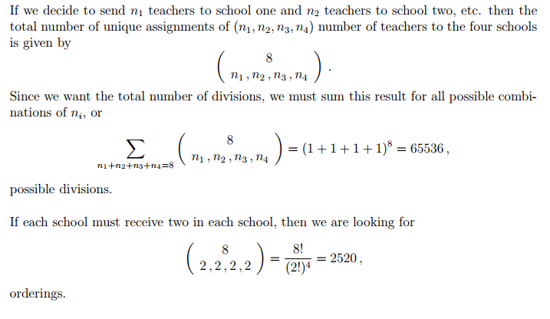

**2. Find the of:**

1. 



1. 



1. 

Because , we calculate the first-order derivative of two sides of the equation with respect to 

We get



So



1. 



Calculate the first-order derivative of  with respect to , So



So



**3. Find the Laplace Transform** **of:**







Based on the linearity property of Laplace transform, we can calculate each term independently. Hence:



From the previous exercise, we get:



And



So



**4. Prove:**

1. 



1. 



1. 

Integration by parts



Let





We have:



**5. Solve the following differential equations (using Laplace Transform):**



If , then based on the property of Laplace transform we have



So



Since , we get



So



According to the first exercise, we can get

